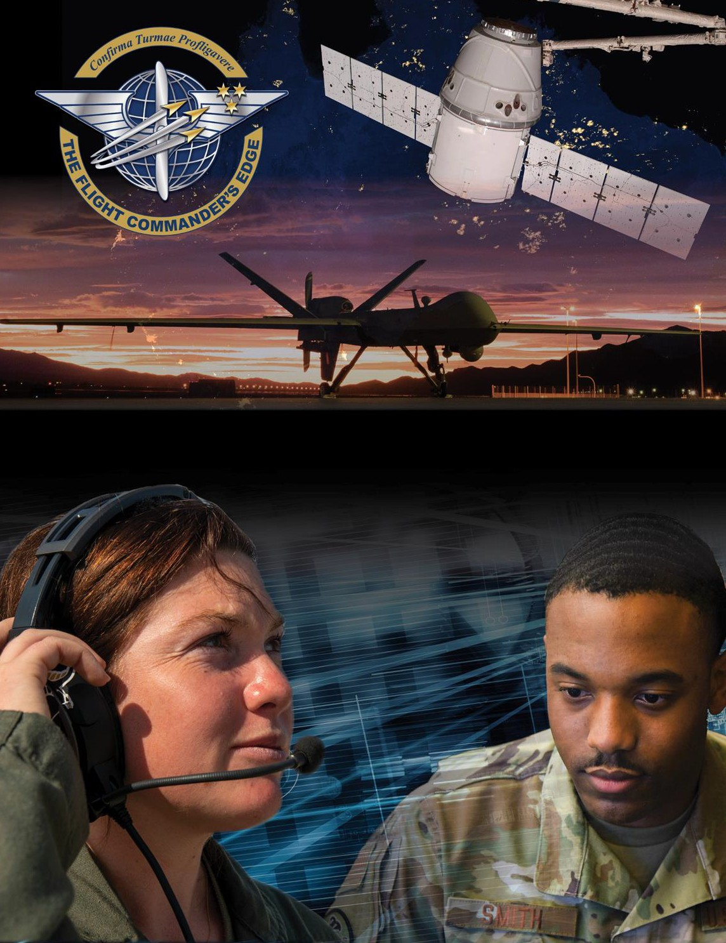

Lesson Guide

Professional Development

***14 April 2025***

# Professional Development

**Purpose**

This lesson guide is designed to support the local development of Flight Commander Leadership Course materials. Selected facilitators should use this guide as they prepare presentation materials. For more information on how lessons are structured, or how to use them in the course, see the ***Course Director’s Handbook*** or online Facilitator Resources.

# Scope

Professional development is a critical need for any member of the armed forces as we seek to continually develop ourselves and our Airmen and Guardians to lead and execute in a rapidly evolving global environment. Significant differences exist in Professional Development among officers, enlisted, and civilians which must be accounted for when mentoring or advising each member of your team.

As a Flight Commander, you must keep your team members aware of and current in training and educational requirements for their rank/position. You must also encourage and assist them in seeking opportunities to further themselves both personally and professionally. As an officer, Professional Development includes technical and graduate education, Professional Military Education (PME), and experience-broadening programs occurring throughout one’s career. On the enlisted side, PME, educational programs such as the Community College of the Air Force (CCAF), and various self-improvement programs are all considered Professional Development. For civilians, advanced academic degrees, PME, and specific certification training are all available avenues of Professional Development. As you regularly discuss your team members’ goals with them, you can ensure they take advantage of the opportunities and resources available to prepare them for the next stage of their personal and professional lives.

# Recommended Objectives

By the end of this lesson, the participant should be able to:

1. Understand the major components of the Professional Development continuum for the officer and enlisted corps and for the civil service.
2. Understand the PME milestones for officers and enlisted and which of these are available for the civil service.
3. Highlight the differences in Professional Development opportunities across the officer, enlisted, and civil service.

# Recommended POC / Presenter

* Someone with significant experience supervising and mentoring officer, enlisted, and civil service personnel.

# Recommended Length:

* 45 minutes (inclusive of questions)

# Recommended Approach

* Present informational slides with Q & A

# Lesson Connections

* **Developing Others**-Flight Commanders must afford their team members time and support to accomplish training and education related to professional development. A learning environment which develops team members for future leadership opportunities is crucial.
* **Manning**-Professional Development impacts functional area qualifications, which drive considerations when filling manning positions.
* **Mentoring**-Flight Commanders should advise team members of their education/training options and encourage early accomplishment. Early promotion boards and unanticipated opportunities may make early accomplishment especially important.
* **Enlisted Force Structure**-completing PME and other technical certifications are required to advance within the enlisted force. Each rank comes with an expected level of technical, educational, and professional accomplishment.
* **Civil Service Force Structure**-Civil Service personnel are expected to compete for PME opportunities commensurate with their position/grade. With each grade comes an expected level of technical, educational, and professional expertise.
* **OPRs, EPRs, and Civilian Appraisals**-progress toward and recommendations for professional goals should be documented on annual performance reports.

# Additional Discussion

Consider making a compare/contrast handout highlighting the differences, similarities, and timing between professional development for enlisted, officer, and civilians.

Poll your participants to gain a variety of ideas for professional development. One idea is to have your audience look at the Ira C. Eaker Center for Leadership Development website to see what courses are offered for civilians, enlisted, officers, and senior leaders across the DAF.

Ask

“What role does community involvement play in Airmen and Guardian’s Professional Development and career prospects?”

“How will you incorporate resources available from *The Blueprint* within your flight?”